ROBOT CLASS IN AUTOMATION TESTING

A Brief Overview on ROBOT Class

Robot class is a separate class in Java which allows us to perform multiple tasks based on our requirement. The Robot class in the Java AWT package is used to generate native system input events for the purposes of test automation, self-running demos, and other applications where control of the mouse and keyboard is needed.

A Detailed Overview on ROBOT Class

There are multiple ways to upload any type of files in Selenium WebDriver-

a. We can directly use sendKeys(“File path”) method but sometime this methods does not work

b. We can use Robot class to upload files in Selenium

Robot class is not part of Selenium, it comes with Java but we can use the same at the time of preparing automation script using Selenium. We have to use some keyboard events to perform the file upload operation successfully. It generally throws AWT exception, so we need to deal with it accordingly.
Using Robot class, we can simulate keyboard events in Selenium. The primary purpose of Robot is to facilitate automated testing of Java platform implementations. We will have to use methods of robot class to use the same.

Why Robot class is used in Automation Testing?

Sometimes we need to control mouse & keyboard to connect with window in the testing process. For example, to handle file upload, download & pop-ups. These windows applications are not handled by Selenium WebDriver. To handle these, Robot class is required which interacts with OS pop-ups. So, we can summarise & say that the Robot Class is used to-

a. Simulate mouse & keyboard events
b. Support Selenium WebDriver to download or upload a file.

Pre-requisites for using the Robot class

a. Below mentioned packages needs to be imported-
- import java.awt.AWTException;
- import java.awt.Robot;

b. Create object of the Robot class-

Robot robot = new Robot();

Popular Methods used in ROBOT class for Selenium WebDriver

A brief about each method-

a) keyPress()- To press any key
Ex: robot.keyPress(KeyEvent.VK_UP): Presses UP key in keyboard

b) keyRelease()- To release pressed key of keyboard
Ex: robot.keyRelease(KeyEvent.VK_CAPS_LOCK): Releases the pressed Caps lock key in keyboard

c) mouseMove()- To move the mouse pointer to X & Y co-ordinates. Co-ordinates of elements are passed in mouseMove()
robot.mouseMove(coordinates.getX(), coordinates.getY());

d) mousePress()- To press the left button of mouse
Ex: robot.mousePress(InputEvent.BUTTON1_MASK);

e) mouseRelease()- To release the pressed button of mouse
Ex: robot.mouseRelease(InputEvent.BUTTON1_MASK);

f) delay()- To suspend execution for a specified period
Ex: robot.delay(500);

Note- Each key has to be pressed and released respectively. Delay() method works the same as Thread.sleep() in Selenium & causes the current thread to suspend execution for a specified period (in milliseconds).

The basic steps involved in the file uploading process-
Step 1- We have to copy the file location in system clipboard.
Step 2- We have to click on upload button and use CTR+V and ENTER.

The Steps followed for file upload using Robot Class in MAC OS

Below are the detailed steps that are to be followed-

Step 1. Click the upload button on your Webpage and ensure file upload pop-up appears.
Step 2. Create a File object with the file path as an input and assign the absolute path of it to StringSelection object
Step 3. Copy the path of the file in the clipboard by using getSystemClipboard method.
Step 4. Bring GOTO window by pressing Command+Shift+G and assign the clipboard value.
Step 5. Press Enter key to get GO button clicked from GOTO window.
Step 6. Press Enter key to get Open button clicked from File Upload pop-up.

SAMPLE Code to Upload file using Robot Class in MAC OS

// Click on the File Upload Button

System.out.println("Clicking on the Browse and Save button");

WebElement uploadElement1 = driver.findElement(By.id("value of id"));

uploadElement1.click();

// File Need to be imported

File file = new File("Path of the File");

StringSelection stringSelection= new StringSelection(file.getAbsolutePath());

// Copy to clipboard

Toolkit.getDefaultToolkit().getSystemClipboard().setContents(stringSelection, null);

Robot robot = new Robot();

// Cmd + Tab is needed since it launches a Java app and the browser looses focus

robot.keyPress(KeyEvent.VK_META);

robot.keyPress(KeyEvent.VK_TAB);

robot.keyRelease(KeyEvent.VK_META);

robot.keyRelease(KeyEvent.VK_TAB);

robot.delay(6000);

// Open Goto window

robot.keyPress(KeyEvent.VK_META);

robot.keyPress(KeyEvent.VK_SHIFT);

robot.keyPress(KeyEvent.VK_G);

robot.keyRelease(KeyEvent.VK_META);

robot.keyRelease(KeyEvent.VK_SHIFT);

robot.keyRelease(KeyEvent.VK_G);

// Paste the clipboard value

robot.keyPress(KeyEvent.VK_META);

robot.keyPress(KeyEvent.VK_V);

robot.keyRelease(KeyEvent.VK_META);

robot.keyRelease(KeyEvent.VK_V);

// Press Enter key to close the Goto window and Upload window

robot.keyPress(KeyEvent.VK_ENTER);

robot.keyRelease(KeyEvent.VK_ENTER);

robot.delay(6000);

robot.keyPress(KeyEvent.VK_ENTER);

robot.keyRelease(KeyEvent.VK_ENTER);

System.out.println("File Upload has been successful!!!");

Specimen Screenshot for the File Upload operation

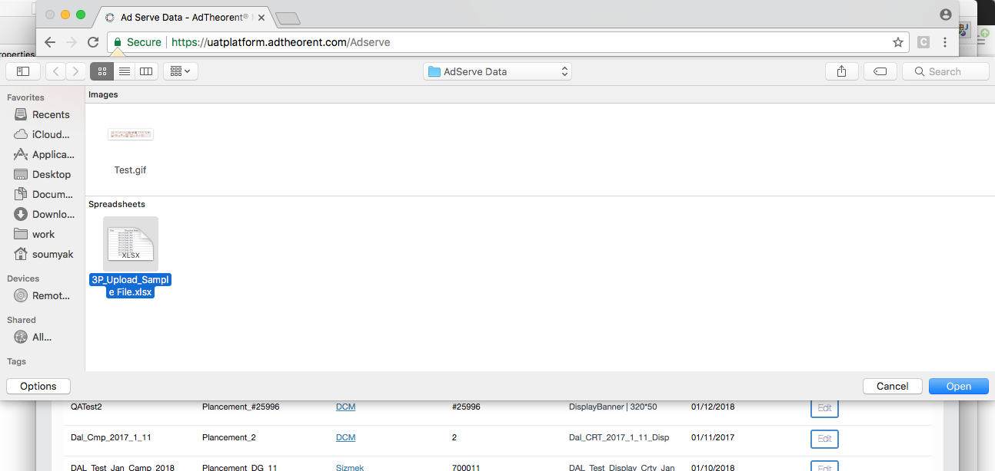

Disadvantages of using Robot Class

a. Mouse or keyboard event will only work on current instance of window. It is difficult to switch among different screen or windows.
For example- A code is executing any robot event but the code execution is moved to other window, in this case mouse or keyboard event will still remain on previous window.

b. Some methods like mouseMove() also depends on screen resolution. So, it might happen that code will not work on other machines.

